PhD Project Opportunity

Dissecting the Role of Mitochondrial DNA Mutations on Phenotype and Fitness Using
Mitochondrial Base Editors

We are currently seeking at least one PhD student with interests in molecular and synthetic biology, genetics, evolution, and ecology to conduct cutting-edge research into the role of mitochondrial DNA mutations on phenotype and fitness using the latest mitochondrial genome editing techniques.

Project Summary: Mitochondria are essential to all eukaryotic life (fungi, protists, plants, and animals). They reside within our cells and serve many functions but are best known for their role in cellular energy production. Normal mitochondrial function is achieved through the cooperative interaction of two genomes: one nuclear and one specific to the mitochondria (mtDNA). In humans and other species, mutations in mitochondrial DNA (mtDNA) have been implicated in degenerative diseases, metabolic disorders, ageing, cancer, and infertility. Despite the growing appreciation of the importance of mtDNA, few studies have yet determined how much of an organism’s physical characteristics (phenotype) are governed by the mitochondrial versus the nuclear genome, and our understanding of the wider roles of mtDNA on organismal fitness and health is surprisingly sparse. Here, we will combine cutting-edge mitochondrial DNA editing approaches with the genetic tractability of the fruit fly (Drosophila), to determine the importance of mtDNA mutations on metabolism, fertility, longevity, and behaviour. Our work will enhance our understanding of the role of the mitochondrial genome on fitness, health, and ageing, potentially leading to new treatments for devastating mtDNA diseases and disorders, improvements in health and longevity, and the identification of new targets for genetic biocontrol.
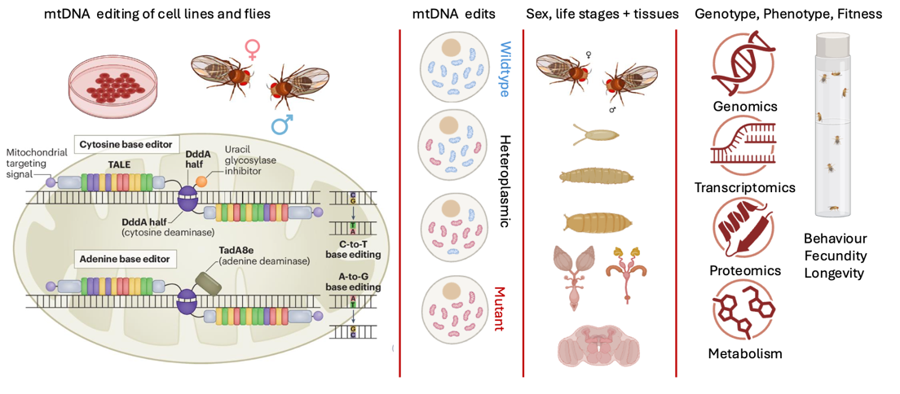
The project emerges from a new Marsden grant headed by Professor Neil Gemmell (Otago, NZ) in collaboration with Prof Damian Dowling (Monash University, Australia) and Professors Alex Whitworth and Michal Minczuk (Cambridge, UK). The PhD position will be based predominantly in the Gemmell lab at the University of Otago, but this project will require work in collaborating labs in the UK and Australia.
Figure 1. Experimental Overview – mtDNA editing to explore phenotype and fitness effects.

The Ideal Candidate: The ideal candidate will possess experience in gene editing approaches, synthetic biology, molecular mitochondrial biology, and have a strong grounding in genetics, genomics evolutionary biology and ecology. Knowledge of entomology, microscopy and molecular genetic approaches and analyses will be a distinct advantage. The successful candidate will be motivated and organised, with a demonstrated capacity to master the broad skill set necessary for the successful completion of a research project. They will be a competent laboratory worker, experienced in all routine molecular genetic techniques, and computer literate with familiarity with database management and statistical analyses.

Minimum qualifications: B.Sc. (Hons) and/or M.Sc. in genetics, genomics, molecular biology, behavioural ecology or equivalent with an A average or better.

Scholarship Funding: Financial support is expected to be available for a high achieving student (normally an A average or better) via a University of Otago scholarship (~NZ$34,128 and tuition fees).

Eligibility: University of Otago scholarships are open to all nationalities. However, overseas candidates for whom English is not a first language must satisfy the English Language Requirements of the University to be eligible for study.

How to Apply: Interested applicants are encouraged to make informal enquiries to Professor Neil Gemmell. Please send a your Curriculum Vitae, a copy of your academic transcript, a sample of your written scientific work and the names of three referees with a covering letter to: neil.gemmell@otago.ac.nz

Further information: Gemmell lab

Applications close on the 30th March and it would be desirable if the successful applicant were able to start by mid 2026.

